MASCOT parameters for regolith bouncing simulations
M1: MASCOT on Hayabusa-2 on Ryugu
M2: MASCOT-2 for AIDA/AIM on Didymos Beta

J. Biele, 29.01.2016

Introduction
In late 2014 the Japan Aerospace Exploration Agency (JAXA) is set to launch the unmanned spacecraft Hayabusa 2, which will arrive at its destination, the asteroid 1999 JU3 (now Ryugu), in 2018. Hayabusa 2 will then release a lander, MASCOT-1, developed by the German Space Agency (DLR), onto the asteroid surface.
ESA is currently developing the AIM mission, with the MASCOT-2 lander to touch down on “Didymoon”, the secondary of asteroid Didymos. MASCOT-2 is a bit bigger than MASCOT (13 kg, 327x297x208 mm³). The target is the secondary of the binary asteroid 65803 (1996 GT) Didymos, an Apollo asteroid (perihelion distance smaller than 1.017 AU, semi-major axis greater than 1 AU) discovered on April 11, 1996 by Spacewatch at Kitt Peak. It has a satellite (“Didymoon”) orbiting it with a period of 11.9 hours, hence the appellation "Didymos", meaning "twin". Both asteroids are assumed to possess a surface regolith layer of rather large particles (“pebbles”).

The parameters of the problem
- MASCOT geometry, interior mass distribution, moment of inertia tensor etc.
- Impact velocity and rotational state (relative to asteroid body-fixed frame)
- Input parameter space (defines scope of work )
- Output parameters to be recorded
- This document

The goal of the project
Determine the post-collisional dynamical quantities (CoG velocity, rotational energy, rotational state, accelerations xyz vs. time at impact, cross sections of post-collisional regolith surface, mass and fate of ejecta) of the lander as a function of its pre-impact quantities and regolith parameters.
Then MASCOT flight dynamics (CNES WP for MASCOT-1, DLR tbc for MASCOT-2) would feed these values into some Monte-Carlo simulation to determine the likely final position and orientation of the lander. An important part is to discuss the physical semblance of the used regolith model with known soil analogues. The task will consist of setting up an existing soft-sphere DEM (discrete element method, i.e. particle simulation) software, formulating the problem in a way solvable by the software, assigning input parameters / parameter ranges to the simulations, running, evaluating and analysing the simulations.

Basic properties of the lander, impact parameters

 | Mass (kg) | Size (mm)  cuboid | Mean MoI (kgm²) | Surface gravity (m/s²) | Bulk density of body (kg/m³) | First touchdown speed (m/s)
MASCOT | 10.0 | 292.2 x 277.4 x 197.3 | 0.1 | 2.5E-4 | 1280 | 0.19
MASCOT2 | 13.0 | 327 x 297 x 208 | 0.13 | 6.4e-5 | 2146 | 0.06

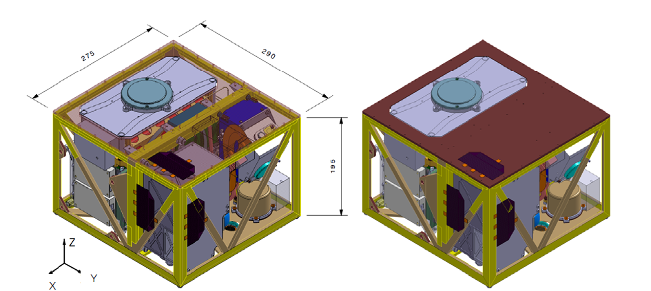
Figure 1 MASCOT lander configuration with dimensions and axis orientation

Modulus of impact velocity at first impact: |v| = 0.19 m/s (MASCOT-1), |v| = 0.06m/s (MASCOT-2)
Angle of incidence: nominally CoG velocity of Lander parallel to surface normal +/- 30° but for secondary bounces, this angle could approach 90°
Rotation before impact: 2 cases
- Zero rotation
- random (phase and axis) rotation with angular velocity of 0.1 rad/s (measured: 0.5..0.8 rpm, so that’s an upper limit)

MASCOT Body Fixed Coordinate System
• The XY plane is located exactly at the outer bottom-face of the baseplate or sepa-ration plane, respectively with the origin in the center.
• The positive Y axis points into the direction of the cold instrument compartment and is parallel to the long side of the lander.
• The positive Z axis points into the separation direction of the MASCOT lander
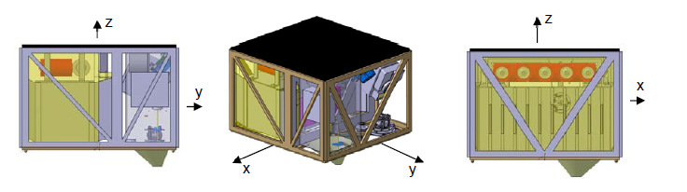
Figure 2 MASCOT Body Fixed Coordinate Definition. Black side up. The µOmega instrument sensor sticking out at –Z is exaggerated in this drawing; it will be neglected.

Mass properties

MASCOT
Total mass MASCOT (landed) 9.662 kg
Final CoG and MoIs are listed below [Update Mascot CoG and MoI_v1.1.pdf 28.5.2015 Chris Grimm]
With respect to CoM:
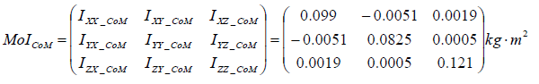
Thus, typically 0.10±0.02 kg m² for a free rotation around one of the main axes.

CoM:
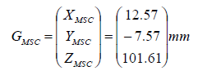

In the MASCOT coordinate system, the inertia tensor is:
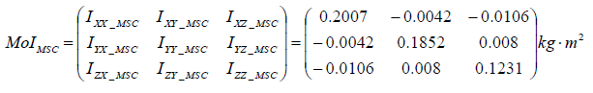
0.2007 -0.0042 -0.0106
-0.0042 0.1852 0.0080
-0.0106 0.0080 0.1231

Eigenvalues and -vectors
From MoI_CoM:
[V,D] = eig(I) % produces a diagonal matrix D of eigenvalues and a
full matrix V whose columns are the corresponding eigenvectors so
that I*V = V*D.

I =[0.099 -0.0051 0.0019;
-0.0051 0.0825 0.0005;
0.0019 0.0005 0.121];

V =

-0.27533 0.95758 0.085034
-0.96102 -0.27647 0.0016687
0.025107 -0.08126 0.99638

D =

0.081026 0 0
0 0.10031 0
0 0 0.12116

I1, I2, I3: 0.081026 0.10031 0.12116 Hauptträgheitsmomente, Mittelwert ist 0.10±0.02

MASCOT-2
Assume mass=13 kg and an MoI enlarged with respect to MASCOT by the factor of 1.57.

Orientation definitions for non-vertical impact
With a non-vertical impact, MASCOT can impact the surface of an asteroid with two different edge orientations:
- An edge orientation along the direction of lateral motion (Edge //)
- An edge orientation perpendicular to the direction of lateral motion (Edge perp.)
ORIENTATION VS INCIDENT ANGLE VS REFLECTION ANGLE
Note: initial approach along the y-axis

Incoming
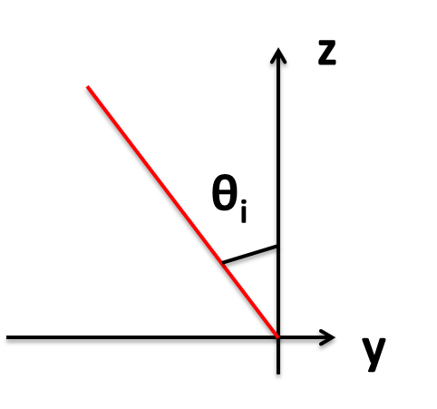
Reflected
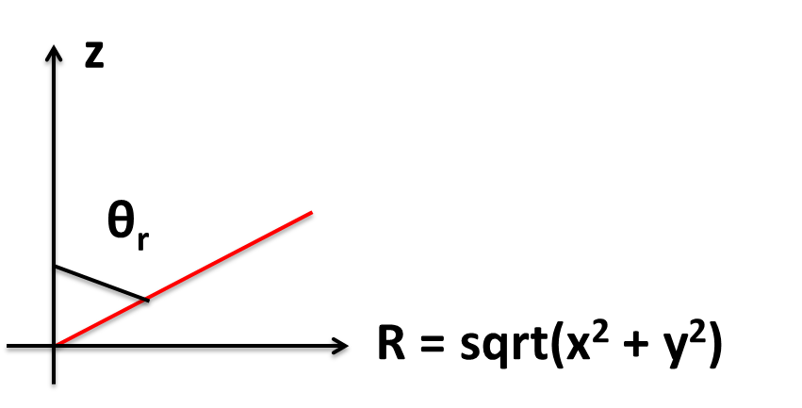

Elastic and damping properties of the Lander
The lander is to be regarded as infinitely stiff, thus also no internal damping can occur. In reality, coefficients of restitution of the order of 0.4 have recently been measured for collision of a MASCOT QM with a vertical concrete wall (pendulum method,~0.1 m/s), and the structural stiffness (elastic) could be estimated as ~50 MPa.

Some approximations
If the lander is treated as a solid box (~cube) with effective diameter=size L, and effective contact area 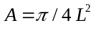. In reality, we have a parallel-epiped with an envelope 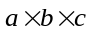 and set
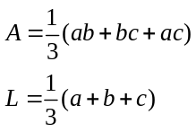
For Mascot, = 295 x 275 x 195 mm³, A=0.070m² and L=0.268 m. The mass is m=10 kg.

The average MoI (referred to the CoG) is 0.13 kgm². The average distance from the edges to the CoG is 182 mm. Thus the average MoI around any of the edges is 0.13+10*0.18²=0.47 kgm².
Landing on the lander vertices or edges would lead to a penetrating surface increasing from zero to a maximum ~1.4 higher than given here and a corresponding linear increase of resistive force (for a weak soil). However, the resulting torques would tend to turn the Lander around its center of mass (CoM) such that, again, one of the planar surfaces contacts the ground. Timescale for this rotation: If the contact force F_{c}(t) is acting briefly, from t=0 to t=t_{f} with a lever arm of r and an angle between lever arm and contact force direction of ϕ, the final rotation frequency is:
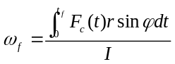
Rotation frequencies in the order of magnitude of 0.1 Hz already use up all the pre-touchdown kinetic energy ½ mv²≈0.05 Joule.

Input parameter space (defines scope of work)

Scaleable: depends on availabe time & resources (e.g., CPU-time).
Invariant: gravity on the asteroid’s surface
Minimum (max. 2x2x3x(2..4)x2 =48..96 cases)
- vertical impact with 0.06 and 0.19 m/s, (2)
- initial rotation: zero and 1 rpm (arbitrary rotation axis ) (2)
- first impact on one corner, one edge, one face; (3)
- regolith monodisperse with grain diameter 1, 10 and 100 mm; (2-4) [less cases if diameter dependence is nil or weak)
- smooth and angular grains. (2)

Wish list (>100 cases)
- add about 2 smaller velocities like 1/3 and 1/30 of initial speed (for bounces after the first – only if there is a dependence on velocity visible);
- add more impact attitudes (the more, the stronger the dependence on attitude turns out to be)
- regolith now polydisperse, power-law integral size distribution exponent -2.5, with above mean particle sizes and lower and upper size cutoffs tbd

Output to be recorded
The key collisional quantities to keep track of are:
- rotation state: rate (scalar), and axis of rotation (vector)
- rotational energy
- Center of gravity velocity
- acceleration (in CoG) during impact (interesting for design of accelerometer payloads)

- DEM description (particle sizes, parameters, number of particles and bed size used in simulations, method of particle arrangement before impact eg. Random ballistic deposition, estimation of edge effects
- Incoming modulus of CoG velocity, angle, attitude, rotation rate and axis
- Outgoing modulus of CoG velocity, angle, attitude, rotation rate and axis
- Movies and snapshots of simulations
- Ejecta:
  - Definition 1: ejecta = bed particle with a positive z component of the speed at the end of the bouncing simulation
  - Definition 2: ejecta = bed particle with cog above the surface of the granular bed at the end of the bouncing simulation [CONSERVATIVE]
  - Definition 3: ejecta = particle with a positive vertical velocity > 1 cm/s (Rygu) >0.2 cm/s (Didymoon).
  - Goal: analyse the crater formed + fate and total quantity of ejecta

Notes
- When exploring the space of particle (friction, shape, etc.) and pre-collisional parameters (velocity, rotation, etc.), we are only interested in effects that change the post-collisional quantities by an order of >~ 10%. This criterion should drive further sweeps into the parameter space.
- The surface environment on 1999 JU3 (diameter=800 m) and “Didymoon” (diameter=150 m) are likely different*. We would expect to find coarser regolith on smaller asteroids, and some observations point to a trend of higher thermal inertia (~ larger grains) on smaller bodies. While thermal inertia has been measured for 1999 JU3, there is no information for Didymoon.
Initial simulations will use similar regolith properties for MASCOT-1 and MASCOT-2. These may be revisited later on when more knowledge on the surfaces is available. For now, key limiting cases (hard and soft surfaces) will be tested that will be relevant to both missions.
- We might want to limit the simulations to mono-disperse distributions of particle sizes of 1, 10, and 100 mm. 0.1 mm grain size would require N~10 billion particles to simulate, and this particle size is sufficiently small that van der Waals forces would dominate short range interactions. We might be able to provide some insights on this regime with scaling arguments (we will need to revisit this regime in the future).

*According to Gundlach&Blum, A new method to determine the grain size of planetary regolith, Icarus 223 (2013) 479–492, the ratio of grain sizes for the two targets (since a factor of ~5 in surface gravity which scales with diameter) is <2.

Appendix

THE COEFFICIENT OF RESTITUTION
The process of rigid body collision is very complicated. The major characteristics are the very short duration and the large magnitude of the forces generated. Other phenomena include vibration waves propagating through the bodies, local deformations produced in the vicinity of the contact area, and frictional and plastic dissipation of mechanical energy. The COR simplifies the energy dissipation description during the complex plastic-elastic contact interaction of colliding solid bodies. Two different approaches can be distinguished for impact and contact analysis: The impulse-momentum or discrete methods (confined primarily to impact between rigid bodies), and the continuous or force based analysis (which is more general). The coefficients of restitution (COR) and other lumped parameters are the primary descriptive variables in the discrete methods, but can be derived only from the continuous method (for simple bodies with a with a known or assumed compliance model, see e.g. ) or by experiment (what we will try to do here).
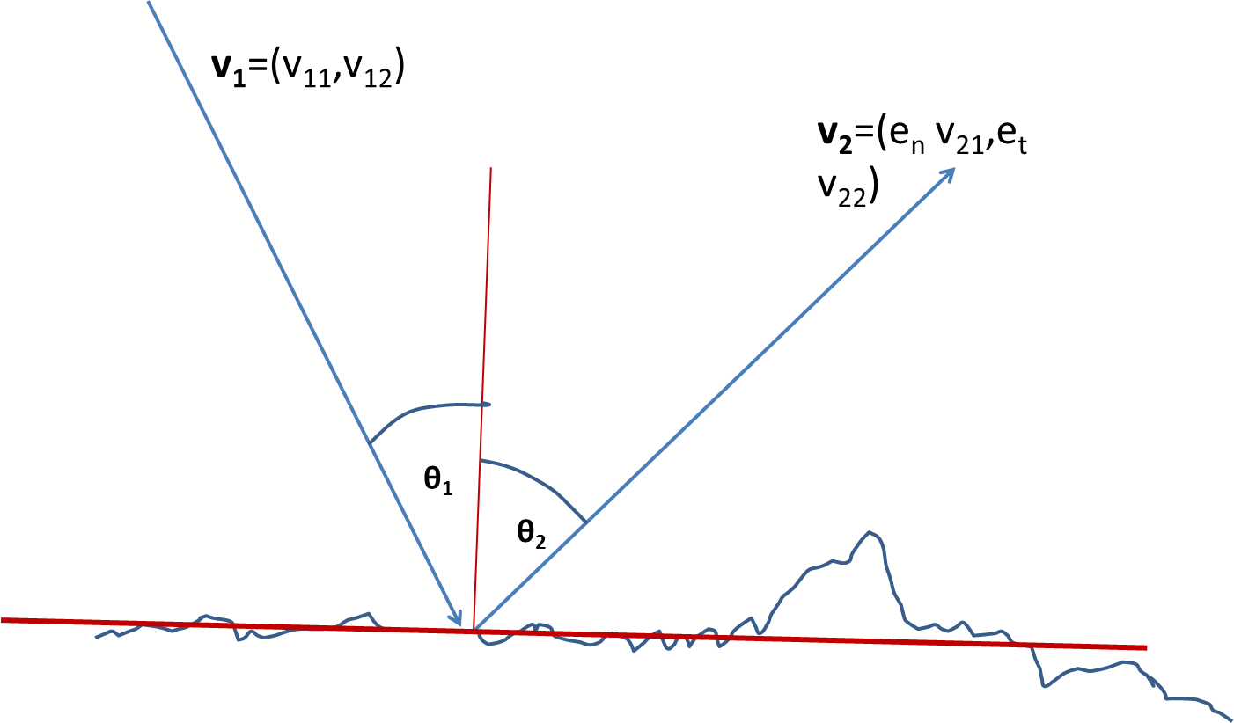
Figure 3 Sketch of bouncing. Lander, treated as point mass, touches the surface at P (at angle θ₁ to the surface normal n) with incoming velocity vector v₁ and bounces off at angle θ₂ to n with outgoing velocity v₂. The surface normal refers to a size scale >> dimension of Lander. Surface roughness on scales of Lander and below is indicated by the blue “real” surface, it determines the probability distribution of θ₂ and influences the rotation change of the real lander. v₁ , n and v₂ do not necessarily need to lie in one plane.
The concept of a COR was first expressed as the Newtonian (kinematic), then as the Poisson (kinetic), and finally as the energetic COR . These definitions are equivalent unless there is friction and the direction of sliding changes during the collision; in this case, only the energetic COR correctly accounts for all sources of energy dissipation.
We use the Newton’s kinematic definition of the normal coefficient of restitution e_{n}:
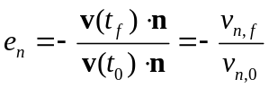
where v is the vector of relative linear velocity at the contact point, t₀ is the start of the contact, t_{f} the end of the contact. is the surface normal at touchdown. Thus, e_{n} is defined as the ratio of the relative normal speed of separation to the relative normal speed of impact. From now on, we will write simply e for e_{n}. A rebound angle can be defined as the angle between 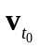 and 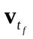 which is generally not 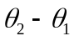 since the incoming and rebound velocity vectors do not have to lie in the same plane with .
Note that e_{n} must be >0 and can be >1. The latter, at first glance paradoxical case has been discussed many times in the rock fall community (see, e.g., and is explained by conversion of lateral impact velocity and/or rotational energy into normal rebound velocity, i.e. the absolute rotation rate must decrease during a bounce and/or 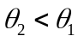 .
A tangential coefficient of restitution can be defined, by analogy, as
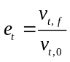 (2)
To calculate the tangential coefficient of restitution, lateral friction is often applied according to Coulomb’s law, 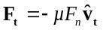.
In the general case of non-elastic collisions between two bodies, we can define a total COR 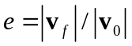 and the energy loss ΔE is related to the coefficient of restitution by 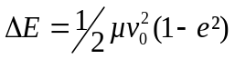 where μ = m₁m₂ / (m₁ + m₂) is the reduced mass and v= |v₂ – v₁| is the relative speed between the two bodies. For perfectly elastic collisions e = 1; in the case of perfectly inelastic collisions, the two bodies stick together after the impact and e = 0. Again, in case of significant rotational energy before the bounce, e can be >1. introduce the notion of a “damping coefficient” equivalent to 1-e.
The presently probably best “instantaneous” surface interaction model is that of which augments the COR with friction and rolling resistance. In particular, MASCOT is not a sphere but a cuboid; the response of a cuboid can be emulated, by choosing a suitable value of the coefficient of rolling resistance. Although the lander shape is modelled as spherical, the value of the coefficient of rolling resistance effectively enables a cube like behavior when the Lander is in lasting contact with the surface: it cannot easily roll. Although this model fails to capture the complex transfer of momentum (rotation/translation) that can happen for a cube during the first few bounces, it should be reliable for approximate statistic estimation and for highlighting deployment trade-offs.

Taking into account rotation

In the literature, the COR is usually measured for impacting spheres, thus it is independent of attitude. In the general case the impact leads to a change of rotation of the impacting body which sensitively depends on the impact attitude, velocity, and the rotational state and moments of inertia matrix J of the Lander [Tardivel, 2013].
Figure 4 shows the possible partition of energy upon an impact. It is readily apparent that the real physical core of the COR is the energy dissipated into non-kinetic energy.

Figure 4 Energy flow associated with an impact of an extended body on a surface 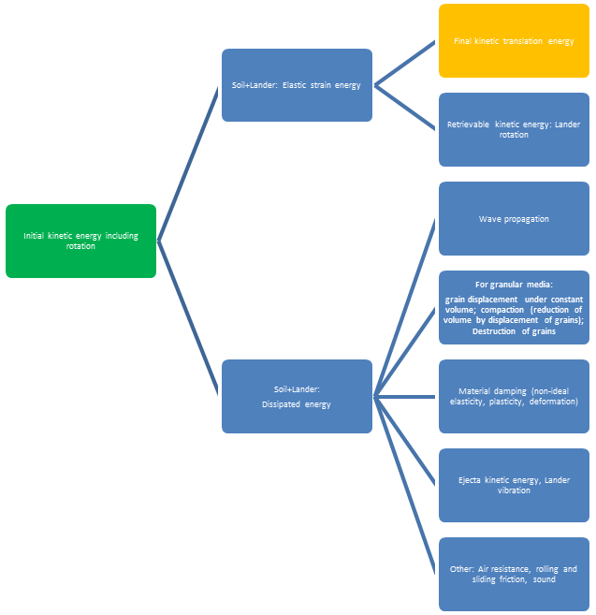

Excess kinetic energy (i.e. rotation and transverse linear motion), however, can be converted into normal linear motion and vice versa; for multiple bounces, this can lead to an apparent change of the effective COR at each bounce even if conditions are perfectly identical otherwise. What we measure here is the “effective” coefficient of normal restitution: this is the usual normal COR as defined above, including any rotational or non-perpendicularity effects. Only the normal velocity of the CoM counts. It could be >1 if enough rotational or transverse kinetic energy is converted into kinetic energy during the contact. A simple model of the partitioning of total damping into rotation as a function of the impact angle is given by .
“Structural” coefficient of restitution e*: COR freed of changes in rotational energy, energy in Y-translation and in the high-frequency mode of pendulum motion. Thus, it is a total (not normal) coefficient. We propose the following definition (E_{kin} = E_{lin} + E_{rot} +E_{osc} is the total kinetic energy including rotation and oscillation):
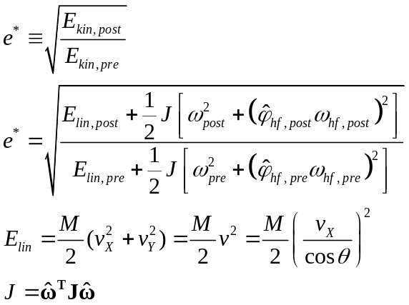 (3)
Thus, ideally we need, for the calculation of e*, not only the perpendicular velocities v_{X}, but also the incidence and emergent angles θ, the mass M and inertia tensor J, the direction (unit vector) of the vertical rotation axis , the rotation rates around the vertical axis and the angular amplitudes and frequencies of the high-frequency pendulum mode.

Velocity dependence

Experimentally it is well known that the COR depends also on the impact velocity. Typically the COR decreases at higher speeds, attains a maximum <1 at a small velocity and goes to zero as the velocity approaches zero (sticking, due to e.g. van-der-Waals forces). According to theory of Thornton and Ning (1998); full analysis in Krijt et al., (2012) for idealized spherical bodies the normalized curves shown in Figure 5 are expected.
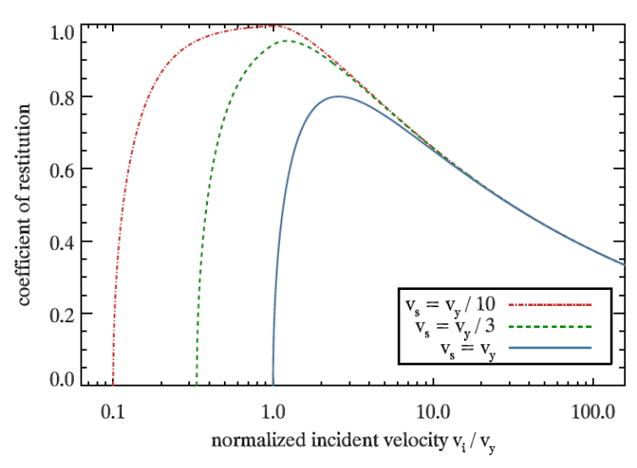
Figure 5 Expected relation for the coefficient of restitution against the incident velocity (after Thornton and Ning, 1998 cited in Güttler et al., 2012)L v_{y} is the so-called yield velocity

Hartmann et al. (1978) showed that catastrophic disruption of an impact target starts at velocities greater 2, 9, 37 m/s for dirt clods, ice and basalt, respectively. In the regime considered here, we are at much lower velocities such that no disruption nor even significant ejecta production is to be expected.
The coefficient of restitution of various rock samples on slabs of the same material is e≈0.86 ± 0.04 for velocities < 1m/s . The coefficient of restitution of 1 m diameter granite spheres is e≈ 0.83 ± 0.06 for collisions between ~1-m-scale spheres at speeds of order 1 m s⁻¹. No clear trend of coefficient of restitution with impact speed was discernible in the data down to velocities of 0.14 m/s. (Durda et al., 2011, Imre 2008). Thus, by close analogy, we conclude that COR(concrete) is e≈ 0.85 ± 0.10.

Composite COR

For collisions between hard bodies that have dissimilar material properties, a composite coefficient of restitution (COR) can be calculated if, for each body, the material properties and COR values for self-similar collisions are known. The composite COR represents the energy dissipated during a collision between materially-dissimilar bodies. This analysis of energy distribution during impact extends the usefulness of the measured values for COR by obtaining the separate dissipation from each body of a collision pair [Coaplen and Stronge, 2004].
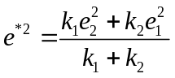(1)
Where the k’s are the compliances (linear rate-independent compliance, yield stress Y (generally better) or elastic module E) and the e_{i}’s the CORs of impacts at the work-equivalent velocity between bodies of the same material. This formula improves/corrects/replaces the formula by Hodgkinson (1834) which has often been referenced (e.g. Goldsmith, Impact, p. 7, eq. 2.14).

Itokawa regolith data
(Michikami et al., 2008)
Cumulative size frequency distribution plots (CSFD-plots)

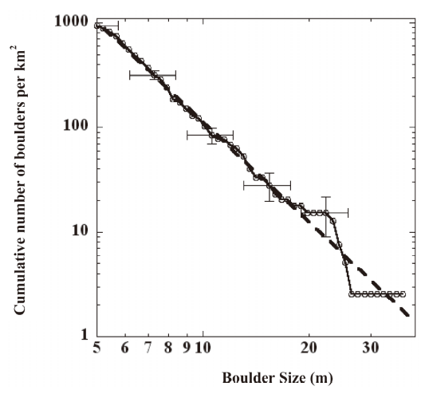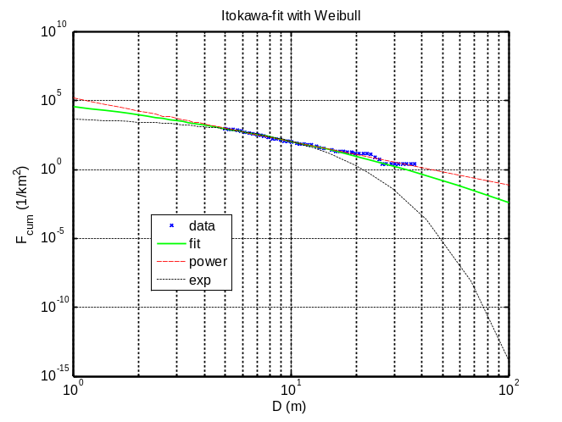
Figure 6 Cumulative boulder size distribution per unit area on the entire surface of Itokawa. The horizontal axis shows the size of the boulder, where the size is defined as the mean horizontal dimensions of the boulder. The vertical axis shows the number of boulders larger than a particular size per unit area. Horizontal error bars indicate the error caused by the scatter among different measurements performed by three people, and is within a tolerance of 15% for the size. Vertical error bars indicate the root of the cumulative number of counting boulders divided by the total area of Itokawa. The error bars are given only for five points to make figure legible. The broken line is a fitted regression line to the data, and the power-law index of size distribution is −3.1 ± 0.1, which is similar to those found on other airless objects (see text). On the right side, the data (points measured from original plot) have been fitted to a Weibull function (green line). An exponential function resulted in a very poor fit for D>11 m.

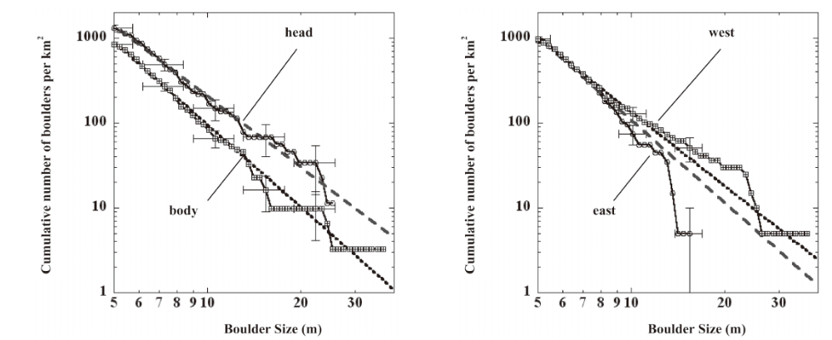
Figure 7 Itokawa, regional. The slope for head is -2.8±0.1, on the body -3.2±0.1, yet the difference is not significant. N(5m) for head and tail are 1300, 850, respectively.

Fit of Itokawa data (global): complementary cumulative Weibull distribution (stretched exponential):
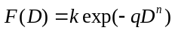
with k=6.05E7, q=-7.44, n=1/4. F was weighted ~1/F.
Since Itokawa was imaged, during sampling, at very high resolution, it would be interesting to have the continuation of the above curves for sizes<5 m. Also, the power index must decline for small sizes (<-2), so maybe this power-fit over not quite one order of magnitude in sizes (40/5) is just an approximation to an exponential or normal distribution covering a much larger size range.
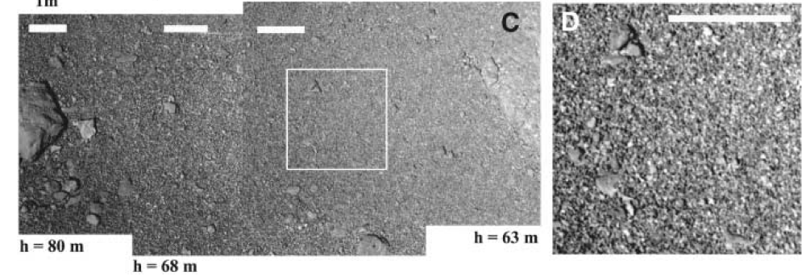
Figure 8 Itokawa closeup images from Yano et al., 2006. Scale bar is 1 m. The spatial resolutions are 0.8 to ~0.6 cm/pixel.

„The surface of Itokawa is likely covered with unconsolidated gravel, which leads us to use terminology of sedimentary deposits (pebble, cobble, and boulder rep-resent objects whose sizes range in 4mm-6.4cm, in 6.4cm-2.6m, and in >2.6m, respectively; gravel includes all of them” [ Miyamoto et al, 2007]

“In total we observed ~20,000 particles of rock materials, whose sizes are ranging from sub cm to ~10 meter. The cumulative size frequency distribution plots (CSFD-plots) for Eros have a log-log slope of -2.0 ± 0.2, matching the size distributions of fragments from laboratory impact experiments, and additionally supporting their putative impact origin [1-2].
The CSFD-plots for Itokawa, show a different trend for each region group. The slope values of the images representing the rough terrain show a mismatch between the low resolution image and the high resolution images, while other regions do not.” [Mayurama et al, 2010]

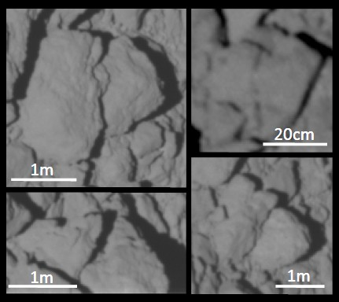
Figure 9 Fractured rock materials are observed in the closeup images. The fractured rock materials may be further evidence of resurfacing of Itokawa by millimeters to centimeters scale micrometeoroid impacts [Takeuchi, 41st Lunar and Planetary Science Conference (2010) 1578]

For small scales on Itokawa, [Hideaki Miyamoto, et al., Regolith Migration and Sorting on Asteroid Itokawa, Science 316, 1011 (2007)]

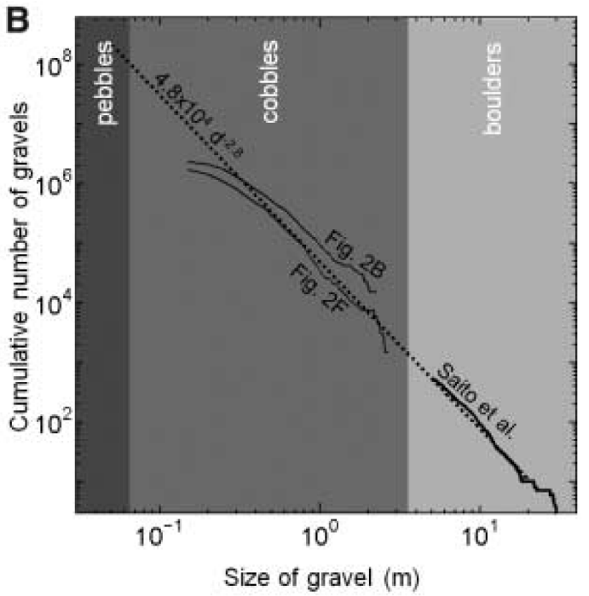
Figure 10 Preliminary cumulative size distributions (maximum horizontal dimensions) of gravels based on 1150 cobbles in images of Fig. 2, B and F, superimposed on the same plot for 534 boulders in global images (6). The distributions generally show a log-log slope of about –2.8 (dotted line), which gives an estimate of the amount of pebbles as 1.9 × 10⁵ m³.

Lately, re-analysed the Itokawa data and find a power-law slope of -3.46±0.03 (differential) and 2.55±0.02 (cumulative), measured for 0.1 m<D< 1m but ok to extrapolate down to 1 cm. They mention the use of R-plot, i.e. the differential data normalized by a -3 differential power law. The saturation (maximum) R-value for many surfaces is ~0.2.
The Hurst exponent for Itokawa is uncertain: LIDAR-derived H=0.27 (smooth), SPC-derived is H=0.88 (rough).

References for appendix
References
RD.. | Bibliographic details
1 | Popov, V.L., Kontaktmechanik und Reibung, 2nd Edition, Springer, Heidelberg 2010
2 | Nagurka, M. and Huang, S., A Mass-Spring-Damper Model of a Bouncing Ball, MARK, Int. J. Engng Ed. Vol. 22, No. 2, pp. 393-401, 2006
3 | Yano, H. et al., Touchdown of the Hayabusa Spacecraft at the Muses Sea on Itokawa, Science 132 (2 June 2006) 1350
4 | Gilardi, G. and I. Sharf, Literature survey of contact dynamics modeling, Mechanism and Machine Theory 37, 1213-1239, 2002
5 | Joshua E. Colwell, Low velocity impacts into dust: results from the COLLIDE-2 microgravity experiment, Icarus 164 (2003) 188–196
6 | Michael Efroimsky, A. Lazarian, Inelastic Dissipation in Wobbling Asteroids and  Comets, MNRAS,Vol. 311, p. 269 (2000)
7 | C. Krause, K. J. Seidensticker, L. Richter, Investigation of Planetary Surfaces with Acoustic Sounding, EGU, Vienna 2007
8 | Sawai , S., Kawaguchi, J., Scheeres, D., Yoshizawa, N. and Ogasawara, M., Development of a Target Marker for Landing on Asteroids, JOURNAL OF SPACECRAFT AND ROCKETS  Vol. 38(4), 601-608, July–August 2001
9 | Hellwege, K.H. (Ed.) Landolt-Börnstein, Numerical data and functional relationships in Science and Technology, New Series, Group V, Vol. 1b: Physical Properties of Rocks. Springer, Berlin 1982
10 | Mavko, G., Mukerji, T., Dvorkin, J., The Rock Physics Handbook, 2nd edition, Cambridge Univ. Press, 2009
11 | Stronge, W.J., Impact mechanics, Cambridge University Press, Cambridge, 2000
12 | Biele, Obstacle size distributions, Technical note TN-1023
13 | Biele, J. et al., The putative mechanical strength of comet surface material applied  to landing on a comet, Acta Astronautica 65 (2009) 1168–1178

